TITLE PAGE

**Table of Contents**

Abstract 1

Introduction 1

Chapter 1 Overview on X-ray detection 1

1.1 Sources of characteristic X-rays 1

• Excitation by radioactive decay 1

• Excitation by external radiation 1

• Synchrotron radiation 2

1.2 Interaction mechanisms of X-rays with matter 2

• Photoelectric absorption 3

• Compton scattering 3

• Coherent scattering 4

• Pair production 4

1.3 X-ray tube 5

1.4 X-ray detectors based on semiconducting materials 8

1.5 Field Effect Transistor as an X-ray detector 9

Chapter 2 Overview on materials 10

Chapter 3 Experimental Methods 10

3.1 MoS2 Samples 10

3.1.1 Fabrication methods 10

3.1.2 IV characterization 10

3.1.3 Characterization under X-rays 10

3.2 TMTES:PS Samples 10

3.2.1 Fabrication methods 10

3.2.2 IV characterization 10

3.2.3 Characterization under X-rays 10

Chapter 4 Results for MoS2 samples 10

Chapter 5 Results for TMTES:PS samples 10

Chapter 6 Conclusions 10

Bibliography 10

# Abstract

Here is the abstract…

# Introduction

This is the Introduction part. Here I include the topic of the thesis, brief description of innovative materials, the goal of the thesis – to understand and to compare two performances of the devices with similar structures, the structure of the thesis.

# Overview on X-ray detection

Here I discuss the general X-ray detectors, thin-film transistors for X-ray detection. Don’t be too long here.//

## Sources of characteristic X-rays

If the orbital electrons in an atom are disrupted from their normal configuration by some excitation process, the atom may exist in an excited state for a relatively short period of time. Eventually, there is a natural tendency for the orbital electrons to rearrange themselves to return the atom to its lowest energy state (ground state) within a time which is characteristically in the range of nanoseconds for a solid material. The energy liberated in the transition from the excited state to the ground state takes the form of a *characteristic X-ray photon* whose energy is defined as the difference between the initial and the final states of the atom (Knoll, 2010).

A large number of different physical processes can lead to the population of excited atomic states from which characteristic X-rays originate. The most common mechanisms include:

* **Excitation by radioactive decay**

In the nuclear decay process of electron capture, the nuclear charge is decreased by the capture of an orbital electron, most often a *K*-electron. The resulting atom still has the right number of electrons, but the capture process also creates a vacancy in one of the inner shells. Once this vacancy is subsequently filled, characteristic X-rays are generated (Knoll, 2010).

### Excitation by external radiation

This method involves an external source of radiation (X-rays, electrons, α-particles etc.) which strikes the target, creating excited or ionized atoms in the target. Since many of these atoms eventually de-excite to the ground state through the emission of characteristic X-rays, the target can serve as a localized source of these X-rays.

As an example, the incident radiation may consist of X-rays generated in a conventional X-ray tube. The external X-rays may then interact with the atoms of a target through photoelectric absorption; therefore, the excited atoms will emit characteristic X-rays creating their X-ray spectrum. This process is called *X-ray fluorescence*.

Another example of incident radiation could be an external electron beam. In this case the characteristic X-ray spectrum from the target will be contaminated by the continuous *bremsstrahlung* spectrum generated by the deceleration of impinging electrons by their interaction with atomic nuclei. For targets of low atomic number, acceleration potentials of only a few thousand volts are required, which allows to use compact electron sources.

The excitation of a target can also be due to heavy charged particles. The interactions of these particles with the target will give rise to the excited atoms, which will subsequently emit characteristic X-rays. For compact and portable sources, α-particles are often used as incident radiation. As α-particle emitters, 210Po and 244Cm are commonly used (Knoll, 2010).

### Synchrotron radiation

Another source of X-rays is performed, when an electron beam is bent into a circular orbit. According to the electromagnetic theory, a fraction of the beam energy is released when the trajectory of the electrons is deflected within a cycle. When extracted from the accelerator in a tangential direction, the radiation appears as an intense and highly directional beam of photons with the energy ranging from visible light (~eV) to X-rays (~104 eV). Although limited to large-scale centralized user facilities, this unique form of electromagnetic radiation is highly because of its high intensity and tunable radiation energy (Knoll, 2010).

## Interaction mechanisms of X-rays with matter

Although a large number of interactions mechanisms between electromagnetic radiation and matter are known, the three major types are usually taken into consideration:

* Photoelectric absorption
* Compton scattering
* Pair production

The common feature of these interactions is partial or complete transfer of the photon energy to an orbital electron, which results in abrupt disappearance of an impinging photon or change of its trajectory by scattering on the electron (Knoll, 2010).

### Photoelectric absorption

In the photoelectric absorption process, a photon interacts with an absorber atom, in which the photon passes its energy to an orbital electron and disappears. Instead, an energetic *photoelectron* is ejected by the atom from one of its bound shells. The photoelectron energy is calculated according to the energy conservation law:

|  |  |
| --- | --- |
| $$E_{e^{-}}=hν- E_{b}$$ | 1.1 |

where *Eb* is the binding energy of the photoelectron in its original shell. In addition to the photoelectron, the photoelectron absorption also generates an ionized absorber atom with a vacancy in one of its shells. This vacancy is quickly filled through capture of a free electron or rearrangement of electrons from the other shells. As a result, one or more characteristic X-ray photons may be generated. In most cases these X-rays are reabsorbed close to the original site through photoelectric absorption involving less tightly bound shells. However, their possible escape from radiation detectors can influence their response. In some fraction of the cases, the emission of an Auger electron may substitute fir the characteristic X-ray in carrying away the atomic excitation energy.

The photoelectric absorption process is the predominant type of interaction for X-rays (and gamma-rays) of relatively low energy. The process is also enhanced for absorber materials of high atomic number *Z*. Although there is no single analytic expression for the probability of photoelectric absorption per atom over all ranges of photon energy *­­Eγ* and *Z*, its rough approximation is present:

|  |  |
| --- | --- |
| $$τ ≅const × \frac{Z^{n}}{E_{γ}^{3.5}}$$ where *n* varies between 4 and 5 over gamma-ray energy region (Knoll, 2010). | 1.2 |

### Compton scattering

In Compton scattering, the incoming X-ray (or gamma-ray) photon is deflected through an angle *θ* with respect to its original direction (Fig.1) by its interaction with an electron in an absorber atom. The photon transfers a portion of its energy to the electron (assumed to be initially at rest), which is then as a *recoil electron*. Since any angle of scattering is possible, the energy transferred to the electron can vary from zero to a large fraction of the impinging photon energy (Knoll, 2010).

The expression that relates the energy transfer and the scattering angle can be derived by combining the energy and momentum conservation laws:

|  |  |
| --- | --- |
| $$hν^{'}= \frac{hν}{1+ \frac{hν}{m_{0}c^{2}}\left(1-\cos{θ}\right)}$$ | 1.3 |

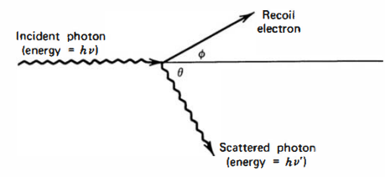

Figure 1.1 Schematic representation of the Compton scattering process (Knoll, 2010).

where *m0c2* is the rest mass energy of the electron (0.511 MeV). The probability of Compton scattering per atom depends on the number of electrons availble as scattering targets and thus, increases linearly with *Z* (Knoll, 2010).

### Coherent scattering

In addition to Compton scattering, another type of scattering can occur, when an X-ray (or gamma-ray) photon interacts coherently with all the electrons in an absorber atom. Such *coherent scattering* or *Rayleigh scattering* process neither excites nor ionizes the atom and the scattered photon retains its original energy, although its direction is changed. The probability of Rayleigh scattering is significant only for low photon energies (usually below a few hundred keV for common materials) and in high-*Z* absorbers. Since the average deflection angle decreases with increasing energy, the practical importance of coherent scattering is restricted to low photon energies (Knoll, 2010).

### Pair production

If the gamma-ray energy exceeds twice the rest-mass energy of an electron ( $E_{γ}≥1.02$ MeV), the process of pair production becomes energetically possible. In this interaction (which must take place in the Coulomb field of the nucleus), the gamma-ray photon disappears generating an electron-positron pair. All the excess energy goes into kinetic energy shared by the positron and the electron. Since the positron will subsequently annihilate after slowing down in the absorbing medium, two annihilation photons are normally produced as secondary products of the interaction. No precise expression exists for the probability of pair per nucleus, but its magnitude varies approximately as the square of the absorber atomic number (Knoll, 2010).

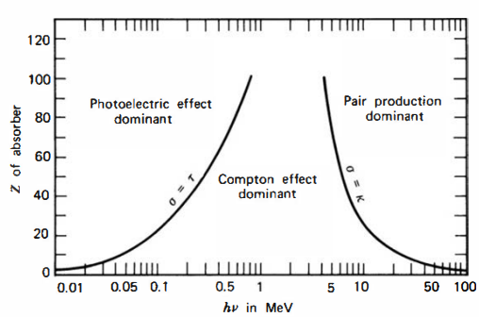

Figure 1.2 Schematic representation of relative probability for different interaction types to occur depending on the *Z* of an absorber atom and on the photon energy *hν*. The lines illustrate the values of *hν* for which the two neighbouring effects are equally probable (Knoll, 2010).

The mean absorbed radiation energy per unit mass of the absorber is the *absorbed dose*. The SI unit of absorbed dose is defined as *gray* (Gy) which is 1 joule per kilogram. The absorbed dose is a reasonable measure of the chemical or physical effects created by a given radiation exposure in an absorbing material (Knoll, 2010).

## X-ray tube

In this section I would like to focus more on a specific device – an X-ray tube, that is broadly used in numerous laboratories and medical departments as a source of X-rays. Since such device was also used during the experimental part of my research, a comprehensive description of the architecture and working principle of an X-ray tube is necessary to have full perception of how the X-ray measurements were performed.

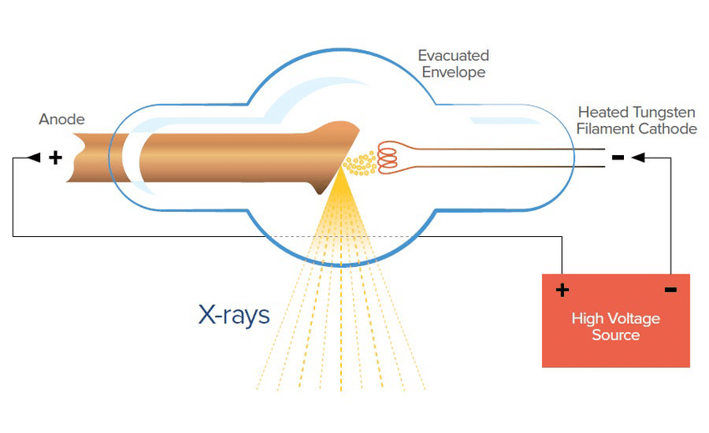

Figure 1.3 Schematic representation of an X-ray tube [1].

As depicted in Fig.1.1, X-rays are generated from the conversion of kinetic energy of electrons into electromagnetic radiation when they become decelerated by interaction with a target material. A high voltage in the range of 20-150 kV is generated between the anode and the cathode inside an X-ray tube. (al., 2020). The negative pole of the voltage is applied to the cathode, considered as the source of electrons, and the positive pole is applied to the anode, which is the target for the electrons. In order to eject electrons from the cathode, a current through a filament at the cathode is generated by a separate voltage circuit. The thermionic emission effect causes the filament to heat up and expel the electrons into vacuum. Once the electrons are ejected, they are accelerated by the X-ray tube voltage and strikes the anode.

At the anode, electrons start to interact with the atoms of the anode. In particular, the positive nuclei start to attract negatively charged electrons, causing their deflection and deceleration and resulting into emission of *bremsstrahlung* X-ray radiation from the anode in different directions. By providing a small window at different angle in the tube, a collimated beam of X-ray photons is obtained (al., 2020), (X-ray Production, Tubes, and Generators, n.d.).

The operational characteristics of an X-ray tube include mainly the voltage and the current between the cathode and the anode. The first one allows us to control kinetic energy of the electrons and thus, the energy of generated X-ray photons. The latter is used to operate the number of electrons impinging on the anode and to vary the number of generated photons. Therefore, controlling both these values allows us to establish the desired intensity of X-rays.

Main factors that affect X-ray production efficiency include the kinetic energy of the incident electrons and the atomic number *Z* of the anode (target material). The approximate ratio of radiative energy loss (bremsstrahlung X-rays) to collisional energy loss (excitation of atoms) is the following:

|  |  |
| --- | --- |
| $$\frac{Radiative energy loss}{Collisional energy loss} ≅ \frac{E_{k}Z}{820,0}, for E_{k}≤150 keV$$ | 1.1 |

where *Ek* is the kinetic energy of incident electrons (X-ray Production, Tubes, and Generators, n.d.). Most X-ray tube anodes are made of tungsten, due to its high atomic number (*Z* = 74) and exceptionally high melting point of 3422 ℃ (WOLFMET, 2024) with a correspondingly low rate of evaporation. In mammography, molybdenum (*Z* = 42) and rhodium (*Z*=45) are also used. For instance, if we consider incident electrons with kinetic energy of 100 keV impinging on a tungsten anode, the ratio of radiative to collisional losses will be ≈ 0.9%, meaning that more than 99% of the incident electron energy gets converted to heat. Consequently, the heat dissipation problem is a significant concern for employment of X-ray tubes (X-ray Production, Tubes, and Generators, n.d.), (Technologies, 2024).

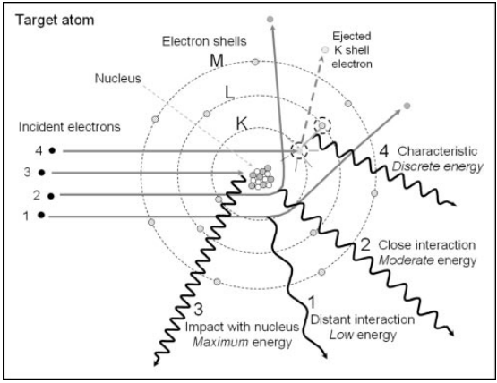Figure 1.4 Mechanisms of formation of bremsstrahlung radiation and characteristic X-rays. Events 1, 3 and 3 demonstrate the interaction of incident electrons in vicinity of the target nucleus producing bremsstrahlung X-rays by the deceleration and deflection of the electrons through Coulomb interaction. Event 4 depicts emission of characteristic X-rays by ejecting of an orbital electron from the K-shell. An unstable vacancy is formed and an outer shell electron occupies the vacancy emitting energy in the form of a characteristic X-ray photon (Seibert, 204).

The X-ray spectrum (Fig.5) output by an X-ray tube consists of discrete characteristic X-rays and continuous bremsstrahlung radiation spectrum with the maximum X-ray energy determined by the potential difference between electrodes. The closer the incident electrons travel to the absorber nucleus, the more intense will be their interaction and the higher will be the emitted photon energy. However, probability of close interaction with the nucleus decreases, thus, decreasing the number of high-energy photons. Therefore, an unfiltered bremsstrahlung radiation energy spectrum is formed the minimum rate at the highest energy and its linear increase with decreasing energy. At the same time low-energy photons are easily attenuated from the beam exiting the X-ray tube window (by Al filters, for example). The measured bremsstrahlung spectrum will have its peak at intermediate energy decreasing to zero at low X-ray energy (Seibert, 204).

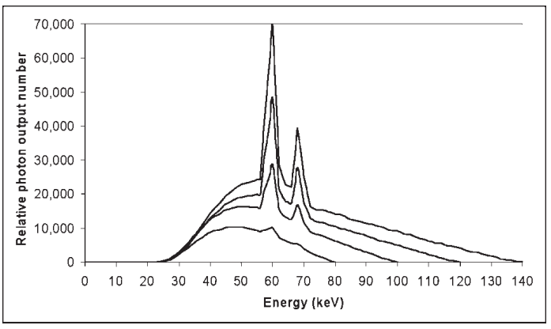

Figure 1.5 Bremsstrahlung and characteristic X-ray energy spectrum for a tungsten anode with the X-ray tube operating at 80, 100, 120 and 140 kV at equal tube current (Seibert, 204).

Discrete characteristic X-ray spectrum is created by the removal of orbital electrons from the target atoms through their interaction with incident electrons. Each electron shell (denoted by K, L, M etc.) have certain biding energies, which for tungsten are 69.5 keV, 11.5 keV and 2.5 keV for the K, L and M shells, respectively. If a highly energetic incident electron has its kinetic energy of at least 69.5 keV, it can potentially eject a K-shell electron leaving a vacancy in the K-shell. Since the atom becomes energetically unstable, another electron for outer shells (L, M, N etc.) will occupy the vacancy in the K-shell (Fig.1.4, event 4), emitting its energy in the form of an X-ray photon. The energy of the photon is defined as the difference in the binding energies of the K-shell and the outer shell. For example, an electron passing from the L-shell to the K-shell will emit a photon with the energy of 69.5-11.5 = 57.0 keV. Since each element has different electron binding energies, the emitted X-ray energies are characteristic of a specific anode element. These characteristic X-rays will create discrete energy spectrum, which shall be added to the continuous bremsstrahlung spectrum. It is worth noting that characteristic X-rays fully depend on the applied voltage, for example, the K-characteristic radiation from a tungsten anode will occur only of the X-ray tube is operated at voltage of ≥ 69.5 kV. As the tube voltage is increased above the minimum value, characteristic X-ray production will also increase its fraction in the X-ray spectrum (Seibert, 204).

## X-ray detectors based on semiconducting materials

The whole multitude of X-ray detection devices might be unified by the principle of creation of charges (free electrons and ions) by passing of X-rays through a material. The most commonly used examples are gas ionization chambers, scintillation counters and semiconductor-based detectors. While the first two types have quite complex configuration, the semiconductor-based devices provide outstanding combination of compact size, high speed, spatial resolution and sensitivity (David Pennicard, 2017). The use of semiconductor materials as radiation detectors can result in a much larger number of carriers for a given incident radiation event that is possible for any other common detector type (Knoll, 2010). The fundamental information carriers are *electron-hole* pairs created by a charged particle or a photon (as primary radiation or its secondary products) in the detector. The motion of generated electrons and holes in an applied electric field generates the basic electrical signal (also called photocurrent) from the semiconductor detector (Knoll, 2010).

Before discussing concrete solid-state X-ray detectors and their architectures, it is good practice to classify the group of semiconductor-based detectors via *direct* and *indirect* detection mechanisms. In the indirect detection, the incident X-ray energy is converted into an electrical signal through a two-step process by using a scintillator material (commonly it is CsI or Gd2O2S (A. Datta, 2020)). In the first step the X-ray radiation impinges on a scintillator, which converts the incident radiation into visible photons. In the second step, a photodiode converts the visible photons into an electrical signal. In the direct detection, the incoming radiation is converted into photocurrent directly in a semiconductor material. Since in our research a semiconductor active channel was used to directly generate photocurrent, from now on our discussion will be focused on the semiconductor-based devices employing the direct detection mode (Laura Basiricò, 2021).

To function properly and thus, provide reliable results for any kind of research involving X-rays, a basic direct semiconductor-based X-ray detector should meet the following requirements:

* A small enough band gap that would stimulate the formation of electron-hole pairs and therefore, increase the total photocurrent providing higher signal-to-noise ratio;
* A high atomic number *Z* for better interaction with incident X-ray radiation;
* High resistivity and low leakage current for lower noise current;
* High intrinsic mobility-lifetime *μτ* product to increase the fraction of charge carriers which successfully reach the electrodes before recombination;
* Homogeneous and defect-free medium to enhance charge transport properties;
* Electrodes that would effectively perform charge collection process and would provide a uniform electric field across the medium.

Currently the most commonly used semiconductor-based (or *solid-state*) X-ray detectors are based on inorganic semiconductors, such as silicon, germanium, gallium arsenide, cadmium telluride CdTe and cadmium zink telluride (CZT) (Laura Basiricò, 2021), (David Pennicard, 2017). Even though these materials provide satisfactory performance for X-ray detection, they still suffer from numerous limitations, such as inflexibility and difficulty to grow large-scale crystalline structures, which prevents their usage onto flexible widespread substrates. That makes the inorganic solid-state detectors impossible to deposit onto human tissue which could greatly advance radiological measurements. For this reason, scientific community is actively developing novel semiconducting materials that would provide detection performance comparable to their inorganic analogues, in combination with flexibility, large-scale and low-cost production of semiconductor-based X-ray detectors.

In the next chapter I will provide a thorough analysis of some materials that could satisfy the mentioned properties. Nonetheless, the following section I will dedicate to a specific detector architecture that provides the opportunity to retrieve maximum information about semiconductor behaviour under X-rays without deepening too much into complex configuration of the device itself.

## Field Effect Transistor as an X-ray detector

As was mentioned in the previous chapter, a basic X-ray semiconductor-based detector consists of the semiconductor medium (also called as *active channel*), in which electron-hole pairs are created, and conductive electrodes that collect the charge carriers forming a photocurrent signal.

# Overview on materials

Here I discuss the semiconducting materials for the active channel: MoS­2 and TMTES:PS.

# Experimental Methods

## MoS2 Samples

### Fabrication methods

### IV characterization

### Characterization under X-rays

## TMTES:PS Samples

### Fabrication methods

### IV characterization

### Characterization under X-rays

# Results for MoS2­ samples

# Results for TMTES:PS samples

# Conclusions

# Bibliography

(2024, February 05). Retrieved from WOLFMET: https://www.wolfmet.com/tungstenalloys

A. Datta, Z. Z. (2020). A new generation of direct X-ray detectors for medical and synchrotron imaging applications. *Scientific Reports*.

al., S. P. (2020). Production of X-RAYS using X-RAY Tube. *Journal of Physics: Conference Series*.

Christian W. Fabjan, H. S. (2020). *Particle Physics Reference Library, Volume 2: Detectors for Particles and Radiation.* Vienna, Austria: Springer.

David Pennicard, B. P. (2017). Semiconductor materials for X-ray detectors. *MRS Bulletin*.

Knoll, G. F. (2010). *Radiation detection and measurement; 4th ed.* New York, NY: Wiley.

Laura Basiricò, A. C. (2021). Solution-Grown Organic and Perovskite X-Ray Detectors: A New Paradigm for the Direct Detection of Ionizing Radiation. *Adv. Mater. Technol.*

Seibert, J. A. (204). X-ray imaging physics for nuclear medicine technologists. Part 1: Basic principles of x-ray production. *Nuclear Medicine Technology*.

Technologies, O. I.-r. (2024, February 05). *Managing the Heat Produced by X-ray Tubes*. Retrieved from https://xray.oxinst.com/learning/view/article/managing-the-heat-produced-by-x-ray-tubes

*X-ray Production, Tubes, and Generators*. (n.d.). Retrieved from Radiology Key: https://radiologykey.com/x-ray-production-tubes-and-generators